Introduction
Your manager, Tony, wants to make sure that you can detect the widely used LLMNR, NBT-NS and MDNS poisoning tool, Responder. Tony was also informed, after a recent penetration test, that a PowerShell-based Responder variant, called Inveigh, is being used in the wild.
A hunting exercise has been scheduled, where you are tasked with detecting Responder's or Inveigh's presence on the network.
LLMNR, NBT-NS and MDNS poisoning can be seen as a Man-in-The-Middle attack that is similar to ARP poisoning, in terms of the actual outcome. In both LLMNR, NBT-NS & MDNS poisoning and ARP poisoning, the victim will eventually interact with an attacker controlled system. In the case of LLMNR, NBT-NS and MDNS poisoning, the attack may result in the victim's NetNTLM password hash being captured and reused by the attacker.
Following is how LLMNR, NBT-NS and MDNS poisoning is performed, at a high level.
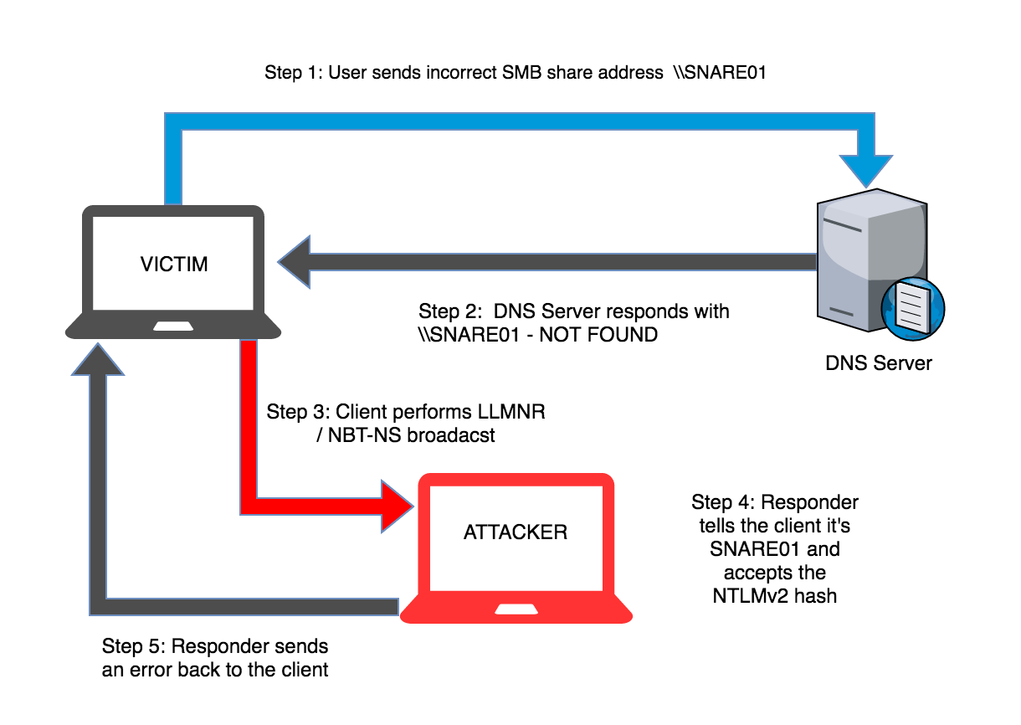Image by: https://www.aptive.co.uk

Goals
You will need to extend the techniques mentioned in the course to detect Responder or Inveigh operating on a network.

What you will learn
The objective of this lab is to use different detection techniques to detect Responder's or Inveigh's presence on a network. Specifically, you will learn to use CredDefense, Honey Credentials (deliberately placed credentials on the network, acting as bait), Sysmon and PowerShell's capabilities, separately, to detect LLMNR, NBT-NS and MDNS poisoning attempts on a network.

Recommended tools
CredDefense (ResponderGuard module)
Powershell (v3+)
Sysmon

Network Configuration
- SERVER01 (the server from where you will start your hunt):
- IP: 10.100.11.150

Domain Credentials: INE\ineadmin | JsZkVjx=xQVEEkY8

Tasks

Task 1: Detect malicious responses and rogue authentication servers inside the network
Responder and Inveigh utilize rogue authentication servers to capture user credentials, after LLMNR, NBT-NS and MDNS poisoning is performed.
By deliberately requesting for a non-existing network resource and using honey credentials, you can detect the presence of Responder or Inveigh inside a network.
The detection can be performed by looking for any responses regarding the non-existing network resource and also by monitoring the usage of honey credentials.
- Detecting ill-intended responses can be performed by checking if a UDP-based response was returned, for the non-existing network resource you deliberately requested. PowerShell and especially the CredDefense suite can assist you in that.
- Detecting the usage of honey credentials can be performed by analyzing a machine's Security event logs. Specifically, the Event ID 4648 - A logon was attempted using explicit credentials can help you in detecting if any honey credentials were used. PowerShell's Get-EventLog (https://docs.microsoft.com/en-us/previous-versions/windows/it-pro/windows-powershell-1.0/ee176846(v=technet.10)?redirectedfrom=MSDN) function will certainly prove handy.

Task 2: Detect suspicious interactions with untrusted IP's
Sysmon is able to collect all interactions of a network asset with other assets in the network. If you query those Sysmon logs for any SMB (or NetBIOS)-related communications with an untrusted IP, you will be able to identify if Responder or Inveigh is operating inside the network.
Specifically, Sysmon's Event ID 3 contains all the information you need to detect any SMB (or NetBIOS)-related communications with an untrusted IP. If the Destination IP is not a trusted File Server or a Domain Controller, chances are that Responder or Inveigh is operating inside the network.
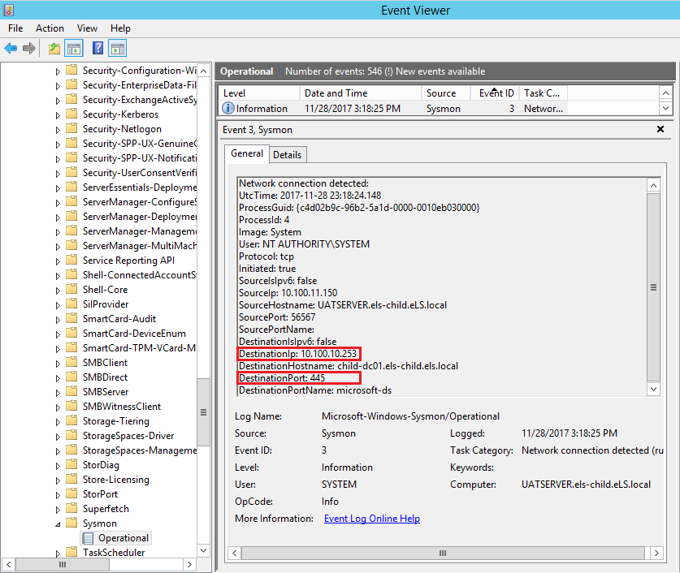

Task 3: Use PowerShell's capabilities to detect Inveigh
Latest PowerShell versions introduced some great blue team-oriented capabilities. One of those capabilities is PowerShell Script Block logging. Script block logging records blocks of code during execution. As a result a script's entire functionality can be recorded and then analyzed. Due to the way script block logging operates, de-obfuscated code can also be recorded, as it is being executed. All logs are recorded into the 'Applications and Services Logs' - Microsoft - Windows -PowerShell - Operational log, under the Event ID 4104.
Inveigh, the PowerShell counterpart of Responder, is considered an extremely effective attacking tool, since it can be executed externally. By enabling PowerShell's script block logging you could easily spot Inveigh running on an endpoint's memory.

Solutions
Below, you can find solutions for each task. Remember, though, that you can follow your own strategy, which may be different from the one explained in the following lab.

Task 1. Detect malicious responses and rogue authentication servers inside the network
Once you are logged in to the lab, open a PowerShell terminal as Administrator, navigate to the Case 1 - CredDefense (ResponderGuard) & HoneyCreds folder, which is located in the Desktop (c:\users\ineadmin\desktop) and execute the following. [ResponderGuard is part the CredDefense suite]
powershell -ep bypass
Import-Module .\ResponderGuard.ps1
Invoke-ResponderGuard -CidrRange 10.100.11.0/24 -LoggingEnabled -HoneyTokenSeed
If you inspect ResponderGuard's code, you will see that it deliberately requests for a non-existing network resource and listens for any ill-intended responses.
You should see something similar to the below.
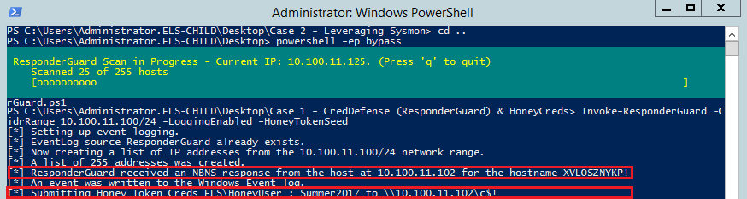
The above means that Responder or Inveigh is present in the network, since we got a response for a non-existing network resource.
Be prepared for false positives like the one below.
ResponderGuard also submits honey credentials to any rogue authentication server of Responder or Inveigh that is detected. So, we can also detect Responder or Inveigh operating inside the network by monitoring the usage of those credentials. As already mentioned the security Event ID that is of interest when looking for such threats, is Event ID 4648 - A logon was attempted using explicit credentials.
We can monitor and query the logs associated with the Event ID 4648 as follows.
First go the machine's Event Viewer and clear all Security logs.
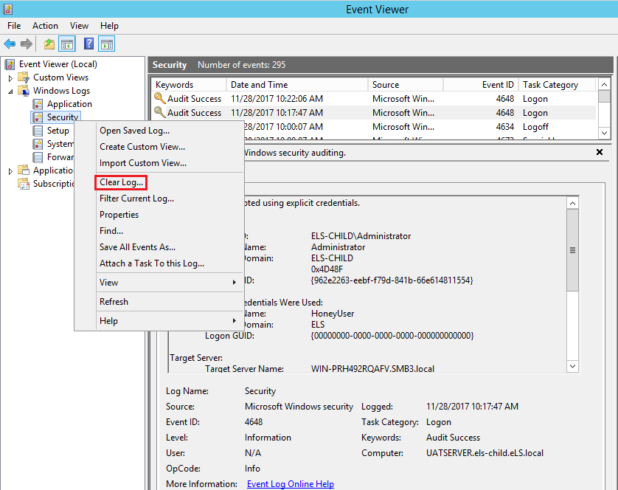
Then open a PowerShell terminal as Administrator, navigate to the Case 1 - CredDefense (ResponderGuard) & HoneyCreds folder, which is located in the Desktop and execute the following. (Or use your existing session if it is still open)
powershell -ep bypass
Import-Module .\ResponderGuard.ps1
Invoke-ResponderGuard -CidrRange 10.100.11.0/24 -LoggingEnabled -HoneyTokenSeed
and concurrently execute in another PowerShell terminal (run again as Administrator) the below
powershell -ep bypass
Import-Module .\Find-HoneyAccount.ps1
Find-HoneyAccount HoneyUser
You should see something similar to the following, once the honey credentials are used.
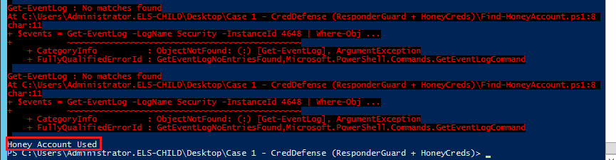
Find-HoneyAccount.ps1 content:
$Print = "Honey Account Used";
function Find-HoneysAccount {
Param(
[String]$AccountName
)
while($True) {
$events = Get-EventLog -LogName Security -InstanceId 4648 | Where-Object { $_.Message -Like "*Account Name:*$($AccountName)*"
}
$events | ForEach-Object {
$_.Message -match "Account Name:(?<content>.*)$($AccountName)" | Out-Null
$Print;exit
}
}
}
This is how you can query a machine’s Security logs using PowerShell

Task 2. Detect suspicious interactions with untrusted IP's
Let's now leverage Sysmon to try and identify any SMB (or NetBIOS)-related communications with an untrusted IP. If the destination IP is an IP other the one of a trusted file server or a domain controller, then Responder or Inveigh may be operating inside the network.
As mentioned, the Sysmon Event ID that is of interest when looking for any SMB (or NetBIOS)-related communications with an untrusted IP, is Sysmon Event ID 3.
First go the machine's Event Viewer and clear the 'Applications and Services Logs' - Microsoft - Windows - Sysmon - Operational log
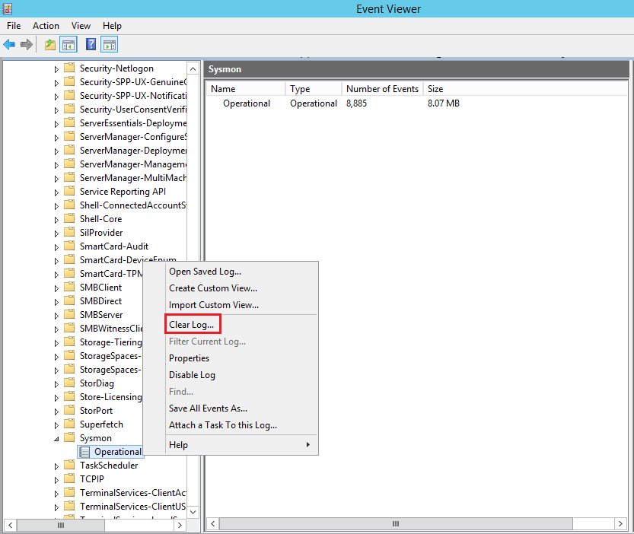
Then, simulate an SMB connection with Responder's rogue authentication server. (This is actually similar to what will happen in the background if Responder is operating inside the network)
Right click on Windows (bottom-right corner) - Run - \\10.100.11.102\c$
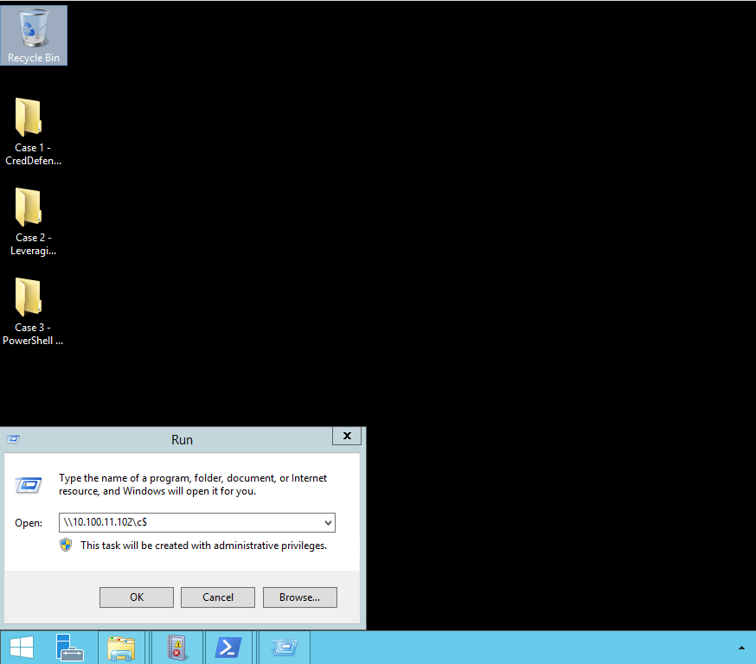
Finally, open a PowerShell terminal as an Administrator, navigate into the Case 2 - Leveraging Sysmon folder, which is located in the Desktop and execute the following.
powershell -ep bypass
Import-Module .\Get-WinEventData.ps1
.\Find-UntrustedSMBConnections.ps1
You should see something similar to the below.
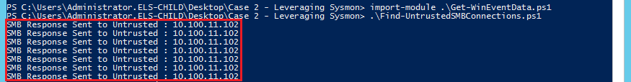
Find-UntrustedSMBConnections.ps1 content:
#credits to haveyousecured.blogspot.gr
Import-Module Get-WinEventData.ps1
Set-Location \\nonexisting\sharenotthere -ErrorAction SilentlyContinue
$EventsID3 = Get-WinEvent -FilterHashtable @{logname="Microsoft-Windows-Sysmon/Operational";id=3} | Get-WinEventData | select EventDataDestinationPort, EventDataDestinationIp
foreach($Event3 in $EventsID3){
if(($Event3.EventDataDestinationPort -eq 445) -and ($Event3.EventDataDestinationIp -notcontains "10.100.10.253")){
Write-Host "SMB Response Sent to Untrusted": $Event3.EventDataDestinationIp
}
}
This is how you can query a machine’s Sysmon logs using PowerShell
You could also use the script above for port 139 (NetBIOS).

Task 3. Use PowerShell's capabilities to detect Inveigh
Let's now leverage PowerShell's Script Block Logging capability. You can enable script block logging on a Windows Server 2012 if Windows Management Framework (WMF) 5.0 and .Net 4.5 are already installed and the following registry key and DWORD are configured, as follows.
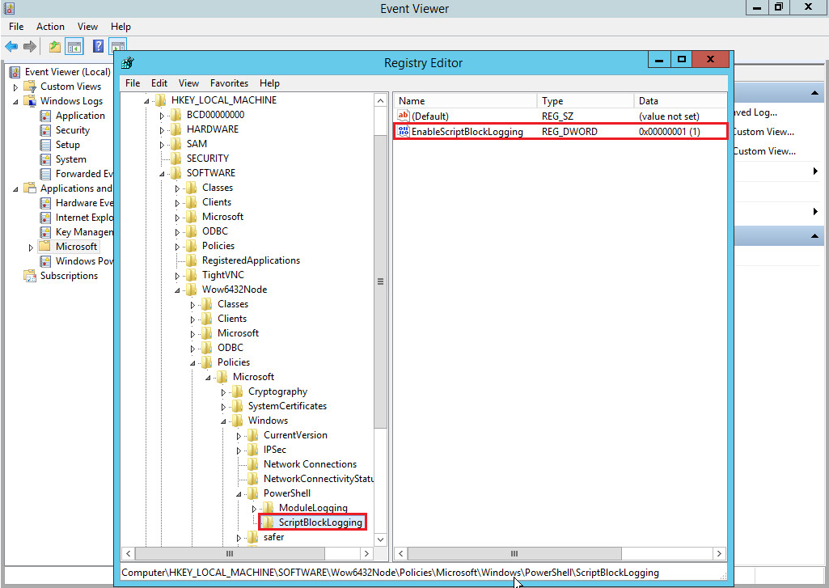
First, open a new PowerShell terminal as an Administrator, navigate into the Case 3 - PowerShell for Blue Teamers folder, which is located in the Desktop and execute the following.
powershell -ep bypass
Import-Module .\Inveigh.ps1
Invoke-Inveigh -IP 10.100.11.150
You should see something similar to the below.
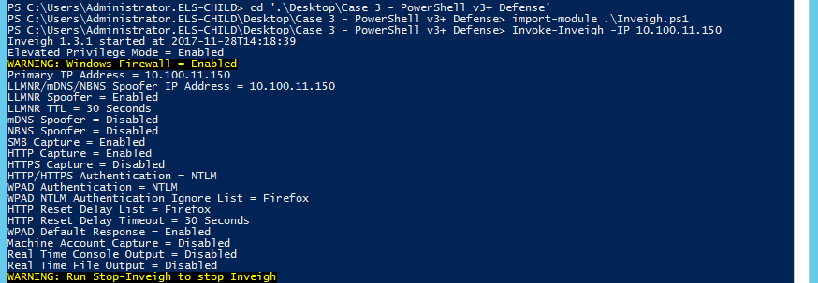
Now, open the machine's Event Viewer and navigate to the 'Applications and Services Logs' - Microsoft - Windows - PowerShell - Operational log.
You should see something similar to the below.
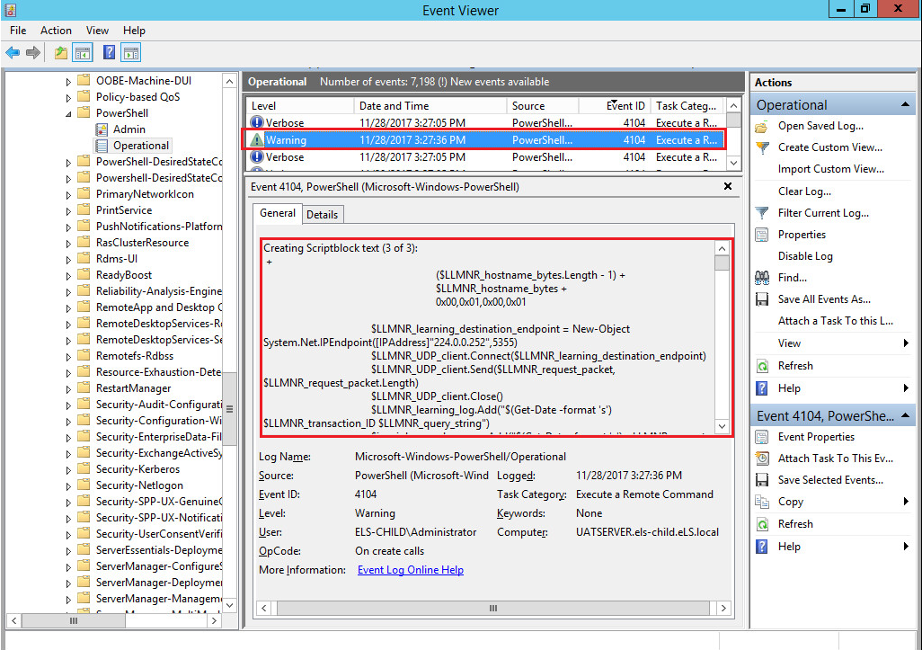
The recorded block above is actually part of Inveigh's LLMNR poisoning procedure.
To conclude, in this lab four (4) distinct ways were documented that could assist you in detecting Responder or Inveigh on a network, under your supervision.
- CredDefense (listening for UDP-based responses when requesting a non-existing network resource)
- Honey Credentials (Security Event ID 4648 )
- Sysmon (Sysmon Event ID 3)
- PowerShell's Script Block Logging (PowerShell Operational log - Event ID 4104)

